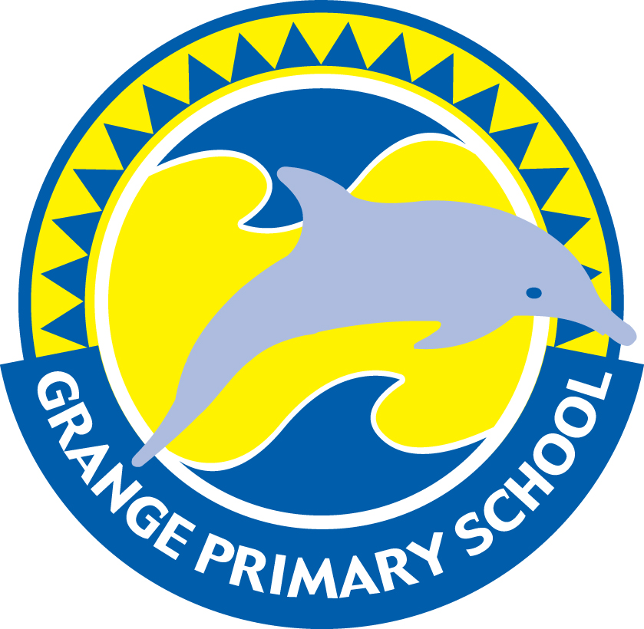
GRANGE PRIMARY SCHOOL
39c JETTY STREET
GRANGE SA 5022
Phone: 8353 2688 Fax: 8235 1326
www.grangesch.sa.edu.au

Health Term 1

Mrs Jasmine Pearce
Room 32

13th February 2017

The Health component of the Health and Physical Education curriculum provides the basis for developing knowledge, understanding and skills for students to lead healthy, safe and active lives.
Students are given the opportunity to learn about their strengths and simple actions they can take to keep themselves and their classmates healthy and safe.

In Term 1 all classes will focus on developing and maintaining a Growth Mindset.
What a child believes about their own ability has a significant impact on their motivation, effort, and approach to challenges. Students who positively believe in their abilities are more likely to embrace challenges and persist despite failure, which is called a Growth Mindset.
However, a Fixed Mindset is when a child believes their intelligence or ability is fixed and do not stretch themselves intellectually, out of fear of failure or embarrassment.

Along with this, there will also be a specific focus based on the particular emotional and physical needs of age groups:

- Year 1 and 2 will describe their own strengths and achievements and those of others, and identify how these contribute to personal identities.

- Year 3 and 4 will explore how success, challenge and failure strengthen identities.

- Year 5 will examine how identities are influenced by people and places.

