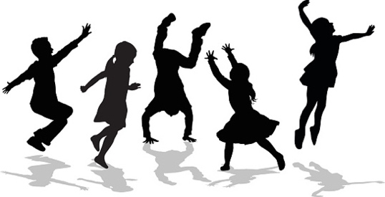

Term 1 2017 Performing Arts Program Year 4 with Diana Busolin.
In 2017 my aim is to create a positive learning environment in music, drama and dance which will incorporate the framework of “Sharing Personal and Social Responsibility” (SPSR).

The SPSR model promotes self and social responsibility by empowering students to take more ownership of their actions. It also encourages them to be concerned about the rights, feelings, and needs of others. The SPSR framework will help students to experience commitment to themselves and others in creating a fun and enjoyable performing arts classroom.
The term one overview for Year 4 Music is outlined below:
Music Outcome | Music Skills Focus | Music Concepts
1.Develop aural skills by exploring, imitating and recognising elements of music including rhythm, pitch, dynamics and form. For example:  Using the ‘Back to School’ theme students will  explore, imitate, recognise, record and improvise rhythm patterns.  2.Practise singing, playing instruments and improvising music, using elements of music including rhythm, pitch, dynamics and form.  3. Listen to music for a purpose and identify the intended purposes of the music. For example: Learn the song for the “Dream Big” festival. Use the elements of music to describe the music. | - Listening and singing.  - Moving to music.  - Playing in time.  - Composing.  - Rehearsing and performing for a purpose.  - Reading music  notation.  - Improvising. | Exploring and understanding the elements of music.  - Beat / Rhythm of Words  - Dynamics(volume)  - Tempo (speed)  - Pitch  - Ostinato (rhythm patterns)

